### **Table 4.2** Brothagar plates containing AZI-Eudragit RS100 nanofibers as well as untreated AZI solution with streak cultures of *S. aureus*

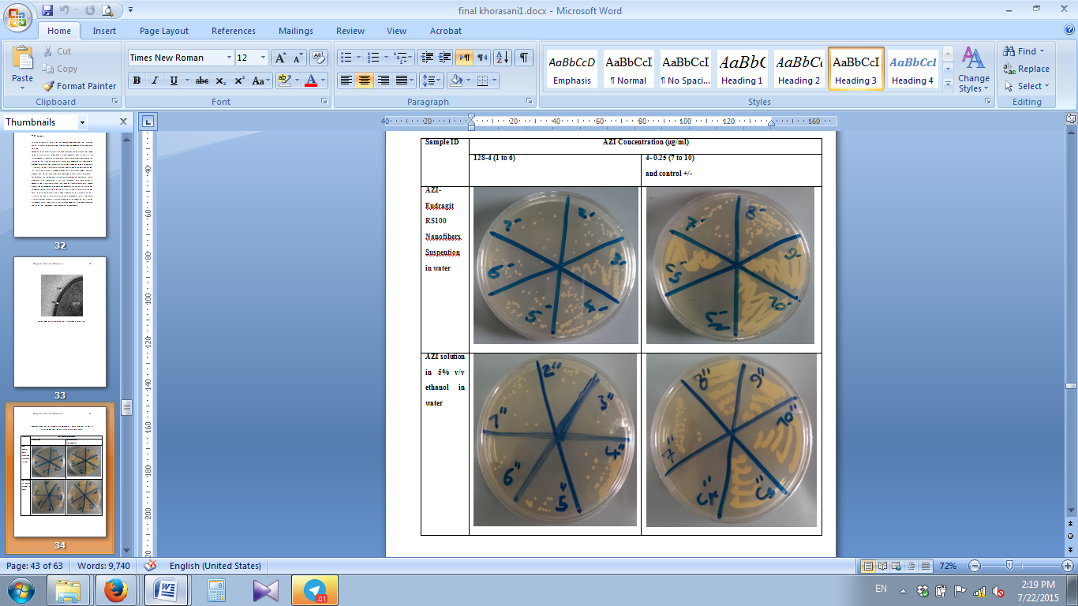

### **Table 4.3** Brothagar plates containing AZI-Eudragit RS100 nanofibers as well as untreated AZI solution with streak cultures of *S*. *paratyphoid*

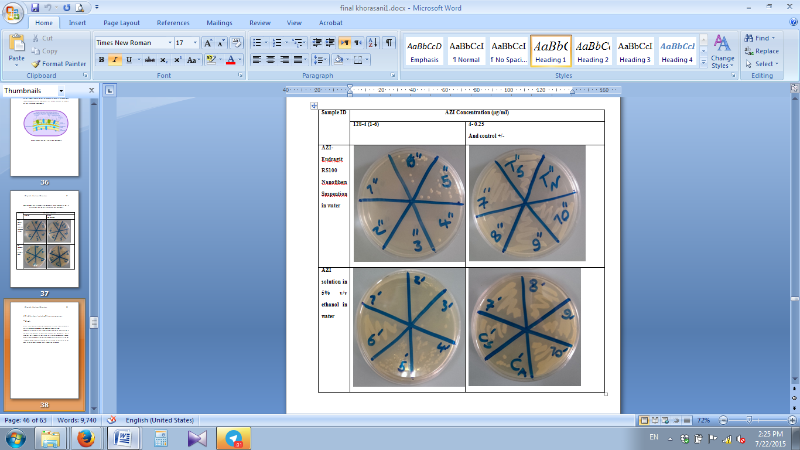

### **Table 4.1 (a and b).** Haemophillus agar plates containing AZI-Eudragit RS100 nanofibers as well as untreated AZI solution with streak cultures of *S. pneumonia.*

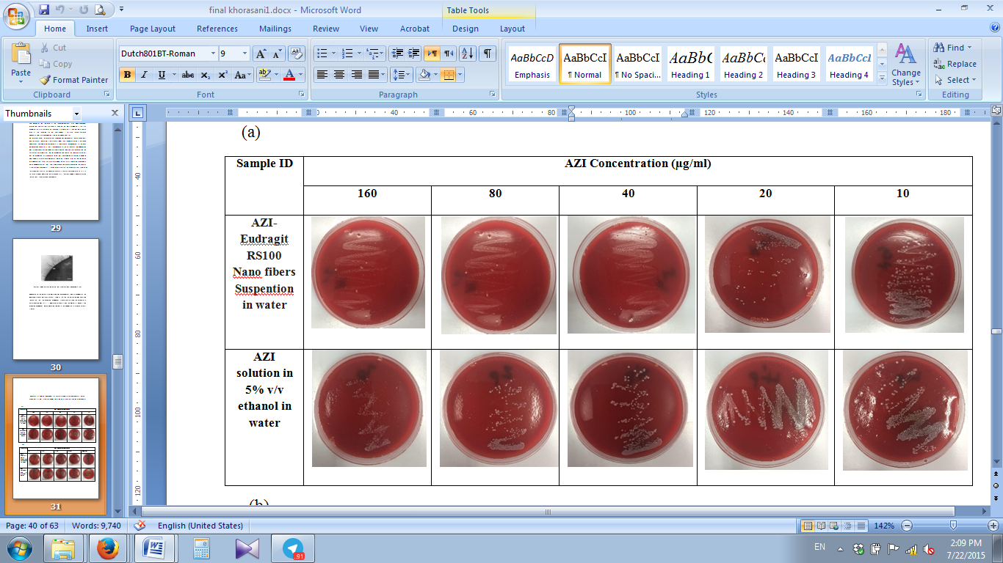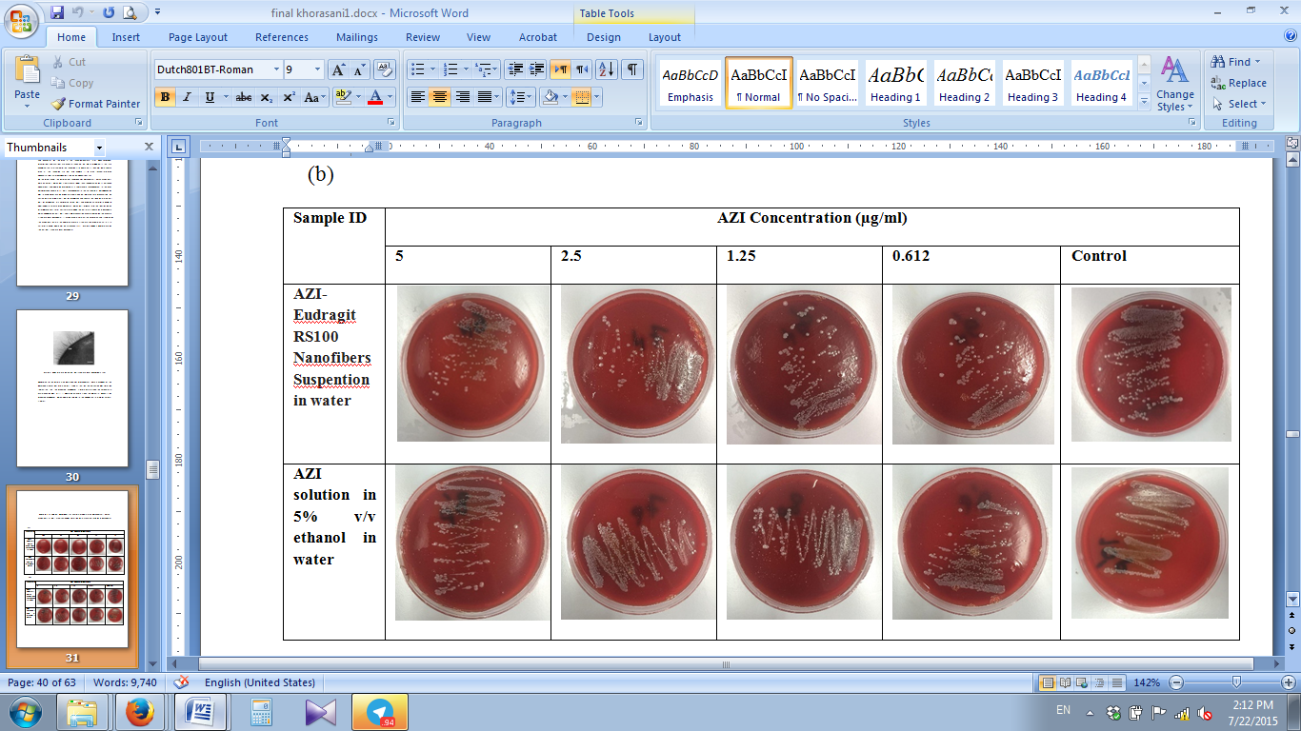

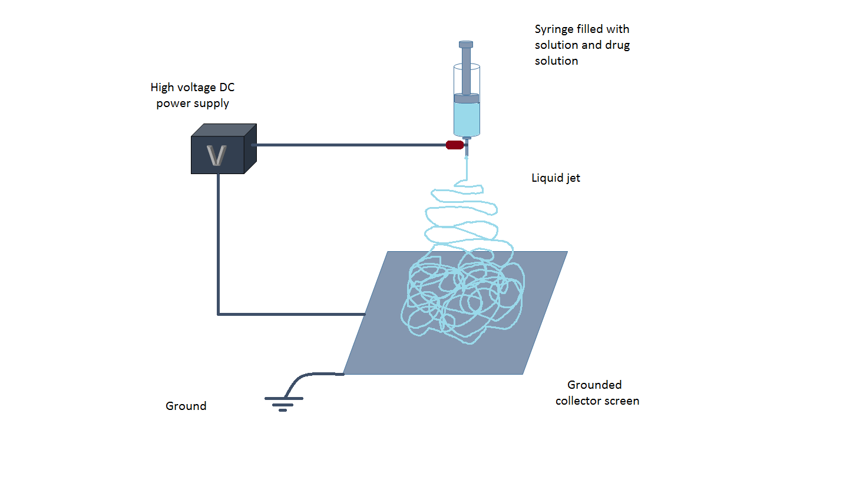

### **Fig. 2.4** Schematic view of electrospinning process

